caBIG®
Clinical Information Suite

Requirements Test Plan

Authors : Brian Bell, Pradeep Dharmavarapu
Ekagra Software Technologies, Ltd
Team : caBIG® QA
Subcontract : 29XS223STO1

Document Change History

Version Number | Date | Contributor | Description
V0.1 | 6/24/2010 | Brian Bell | Initial outline
V0.2 | 10/1/2010 | Brian Bell | Updated state of Analysis artifact review as of RC2-I3-S2
V0.3 | 10/20/2010 | Brian Bell | Updates for consistency with Design & Arch. Test Plans
V0.4 | 2/25/2011 | Pradeep Dharmavarapu | - Changed Requirements Test Plan Template to include additional details  - Update Test Plan with Analysis Spec Verification and Validation Strategy

TABLE OF CONTENTS
Introduction 5
Purpose 5
Scope 5
In Scope 5
Out of Scope 5
List of Analysis Specifications for QA Verification 6
References 6
Assumptions 8
Tools and Repository Locations 9
Tools 9
Requirements Toolset 10
Repository Locations 12
Enterprise Architect 12
SVN 12
Contour 12
Wiki is the face of SVN 12
Quality Center 12
JIRA 12
Tool Access 12
Roles and Responsibilities 13
Analysis DSL/Stream 13
Architecture DSL/Stream 13
Development DSL/Stream 13
QA DSL/Stream 13
Continuous Delivery Operations (CDO) Stream 13
Deployment DSL/Stream 13
Entry and Exit Criteria 14
Entry Criteria 14
Inventory Validations 14
Specification Maturity 14
Exit Criteria 14
Testing Environment 15
Specification Testing Strategy or Testing Methodology 15
Verification Methodology 16
Each Artifact Standalone 16
Consistency between Artifacts 17
Apply ECCF Process Compliance 17
Traceability 18
Testing Maturity 21
Test Case Creation 21
Inputs Considered for Test Case Creation 21
Evolving Process 21
Test Execution 21
Event Handling Mechanism 22
What are Events? 22
Defects 22
Questions 22
Template for Logging Events 22
Risks, Dependencies, Constraints 23
Reporting 24
Sample Reporting Structure 24
Sample Artifact Test Case Distribution Report 24
Sample Execution Status Report 24
Sample Bug Status Report 25

Introduction

Purpose
The National Cancer Institute’s (NCI) Cancer Clinical Information Suite, or caBIG®, project will develop service specifications that will work in concert with existing Electronic Health Record systems to address the unique requirements of the Ambulatory Oncology Community and addresses, in particular, the need for that community to work effectively within the broader research and oncology care environments.

This Requirements Test Plan document describes the methods and tools to be used to confirm:
- Analysis Artifact Stack Quality Assurance and Review
- Requirements Traceability and
- Proof of requirements linkage to System and User Acceptance Testing as required for the Quality Assurance aspects of the caBIG® project.

This version of the document outlines the state of the Requirements Test Plan as of the end of Release 3, Iteration 3 of the caBIG® Clinical Information Suite Project. It will be further updated at the end of Release 4.

Scope

In Scope
This test plan document only specializes in Analysis Specifications Verification and Validation Strategies and Methodologies.
Analysis Specification Testing Methodology that includes –
- Content Verification
- Content Correlation between various ANA artifacts
- Consistency between different ANA artifact types
- Applicable Structural Verifications
- Inventory Verification
- Identifying any Automation Effort using EA plugins or Protégé or any relevant tool
- Test Case Execution in QC
- ECCF Process related impacts on Specification Verification and Validation
- Iteration-by-iteration review of the Analysis Team’s artifact delivery handed off at the end of each project iteration.
- Requirements Traceability

Out of Scope
- Architecture and ESD and/or any other downstream Specification Verification Process or Methodologies
- HL7 and SAIF
- Working knowledge of Enterprise Architect Software
- ARCH (Design) and ESD (Implementation) related topics
- UML Concepts
- Business Analysis Requirements Gathering, Elaboration and Documentation Process
- The process for “iteration review” of Analysis artifacts is handled in the Design Test Plan.
- The process for “iteration review” of Architecture artifacts is handled in the Architecture Test Plan.
- The Analysis and Architecture teams are responsible for requirements traceability through their respective artifacts.
- Compliance activities, as defined in the Master QA Plan.

List of Analysis Specifications for QA Verification
Artifact Type | Category  Representation (MSS)
- CIM | CIM
- Class Diagrams | CIM
- Object Diagrams | CIM
- Package Diagram | CIM
- Requirements Diagrams | CIM
- DAM | DAM
- Event Flow Diagrams | DAM
- Interaction Diagrams | DAM
- PIM Level UCs | DAM
- Requirements Statements | DAM
- State Machine Diagrams | DAM
- Use Case Diagrams | DAM
- Use Case Narrative | DAM
- Use Cases | DAM
- Design Specification Document | n/a
- Scope and Vision | n/a
- Wiki Page | n/a
- Wireframe Document | n/a
- Analysis Publication Manifest | Project Level Artifacts
- Analysis Release Notes | Project Level Artifacts

References
This Test Plan document references the following documents appropriately –
- Master Test Plan Document
- Analysis Knowledge Transfer Session Material
- Specification Maturity and Change Type Document
- Master Service Status (MSS)

NOTE: For Architecture and ESD related specifications, please find –
- Architecture: Architecture Test Plan, Design Test Plan
- ESD: System Test Plan

Relationship with Other Documents
Artifact Log # | Artifact Name |  | caBIG® Team | RFP Deliverable Reference |  | Key inputs / Dependencies | Expected Content
12 | Scope & Vision - Project |  | Analysis |  |  |  | Overall project and business capability scope
19 | Domain Analysis Model | Analysis |  |  | DAM | Use Cases, Data Elements/Concepts | The DAM is a domain analysis Model that depicts the static and dynamic content of the project's domain - caBIG®. The DAM will include the class diagrams, activity diagrams, sequence diagrams and state diagrams.
20 | Quality Requirements Plan |  | Analysis | Software Requirements Specification |  | Deployment Scenarios, Stakeholder input, Product Owner | Reliability, performance capacity, security, extensibility/configurability, industry standards and conformance, client deployment, auditing, data integrity, usability, supportability and general principles (e.g., ROI)
 | Analysis Management Plan |  | Analysis |  |  | Quality Requirements Plan | Detailed requirements capture process
21 | Conceptual Functional Services Specification (CFSS) |  | Arch | TIRA |  | BAM, Use Cases, DAM | Description, Scope, Justification, Structure of Service, Context, Operations, Functional and Semantic Profiles, System Iterations, Conformance and Compliance Statements, Relevant Standards
35 | Service PIM |  | Arch |  |  | Conceptual Service Specification, Relevant Information Models, BAM, Use Cases, DAM | Relationship to CFSS, Information Model, Data Type Definitions, Operations, Profiles, Behavior/Dynamic Model, Conformance Statements, References, and Glossary
76 | Master Test Plan |  | QA | Test plan document |  | Scope/Vision, SAD | Overall Quality Assurance test plan
77 | Component Test Plans |  | QA | Test plan document |  | Iteration plan, Sprint plan, Sprint req’s | Test plan for the sprint level requirements
81 | System Test Plan | QA |  | Test plan document |  | Scope/Vision, SAD, Release Plan | Test plan for the entire system, its components and interactions
90 | Deployment Scenario x Test Plan | QA |  |  | Test plan document | Deployment Scenario x use cases | Test plan to verify deployment scenario, environment req’s & deployment
98 | Architecture Test Plan |  | QA | Test plan document |  | SAD | Architecture artifacts QA process
100 | Design Test Plan |  | QA | Test plan document |  | Design Documents, UML models | Analysis artifacts QA process
102  (merged with #98) | ECCF Compliance Test Plan (CFSS, PIM, PSM) |  | QA | Test plan document |  | ECCF Implementation Guide | How ECCF compliance will be verified for project artifiacts.  ** Note the content of this artifact has been merged with the Architecture Test Plan

For initial, high-level context, the reader is directed to the caBIG® Master QA Plan document (artifact log #76), which describes testing terminology definitions and overall scope and approach to Quality Assurance on the project.

Assumptions
The following are the assumptions made while verifying the specifications –
- Entry and Exit Criteria is met.
- Tooling to support requirements traceability is under evaluation and installation. It is assumed the planned toolset will be successfully implemented.
- Requirements will be loaded into HP Quality Center using JAMA Contour bridge software.
- Sufficient Knowledge Transfer Sessions have taken place to ramp up QA Team members before evaluating Analysis Specifications.

Tools and Repository Locations

Tools
The table below describes each Analysis Artifact being developed using what Tool.
Artifact Type | Built Using
- CIM | EA
- Class Diagrams | EA
- Event Flow Diagrams | EA
- Interaction Diagrams | EA
- Object Diagrams | EA
- Package Diagram | EA
- State Machine Diagrams | EA
- Use Case Diagrams | EA
- Use Cases | EA
- Requirements Diagrams | EA/Contour
- Requirements Statements | EA/Contour
- Analysis Publication Manifest | MS Excel Spreadsheet
- DAM | MS Word Doc
- Design Specification Document | MS Word Doc
- Scope and Vision | MS Word Doc
- Use Case Narrative | MS Word Doc
- Wireframe Document | MS Word Doc
- PIM Level UCs | n/a
- Analysis Release Notes | Text File
- Wiki Page | Wiki Page/Browser

Requirements Toolset
In this section we provide an overview of the key tools required for requirements traceability. The following diagram provides an overview of the key components relating to traceability.

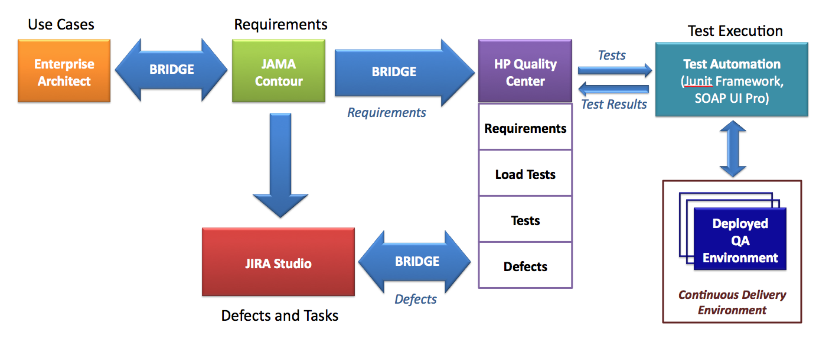

Enterprise Architect (EA)
EA is used primarily by the Analysis and Architecture team to document the design specification. Requirements are identified and linked to Use Cases in Enterprise Architect. An example of requirements for the Referrals service are shown below:

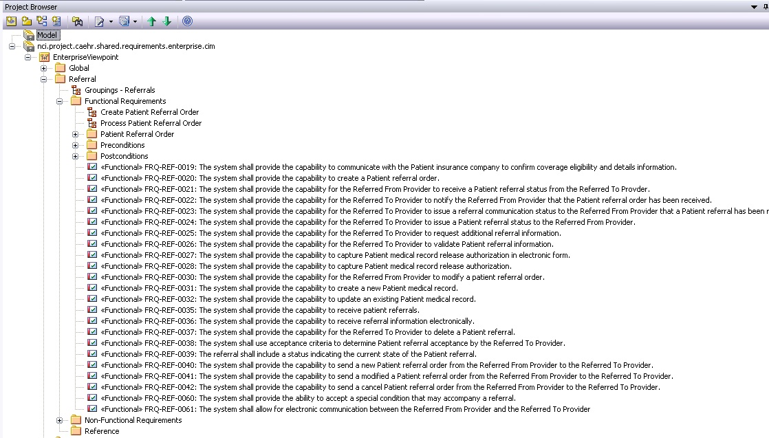

JAMA Contour
JAMA Contour is a requirements management product. JAMA Bridge will be used to connect requirements from Contour to HP Quality Center. Contour has many other features that the A&A team may use including change management capabilities such as version history, side-by-side comparisons, change requests and full activities tracking for auditing. http://www.jamasoftware.com/contour/features.php

HP QC
Hewlett Packard Quality Center will be used for test case management, which includes a defect tracking tool as well. Defects will be entered by QA into the QC defect tracker, and a synchronizer called JIRA Bridge will be used to create corresponding JIRA issues that are synchronized both ways as updates are made.

Illustration of a Requirement stored in HP Quality Center
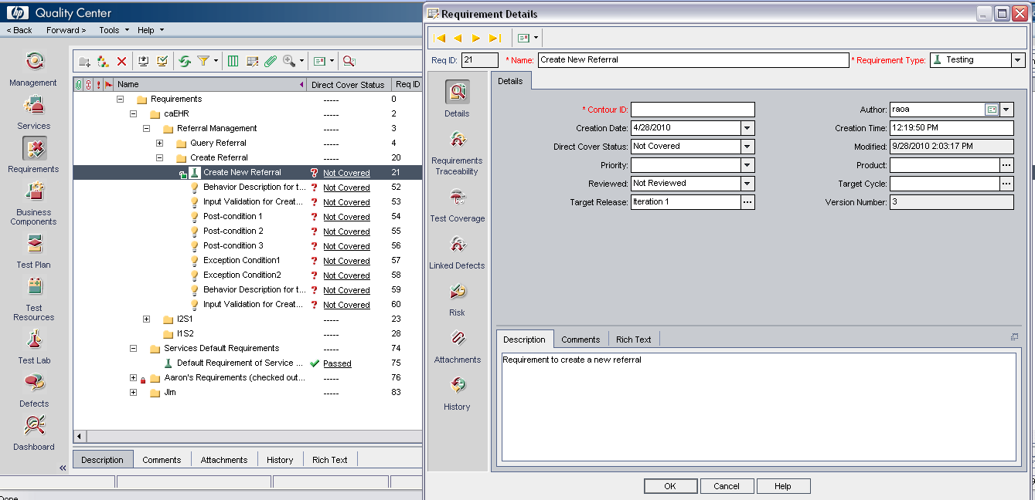

JIRA Studio
JIRA is the central issue and activity tracking tool used by the project to support the Agile development process. It will be the central caBIG® location for all defects. Linkages are planned between JIRA and Contour and HP QC to allow tracking of defects back to test cases and originating requirements.

NOTE: JIRA defect logging template is detailed under “Template for Logging Events” section down below.
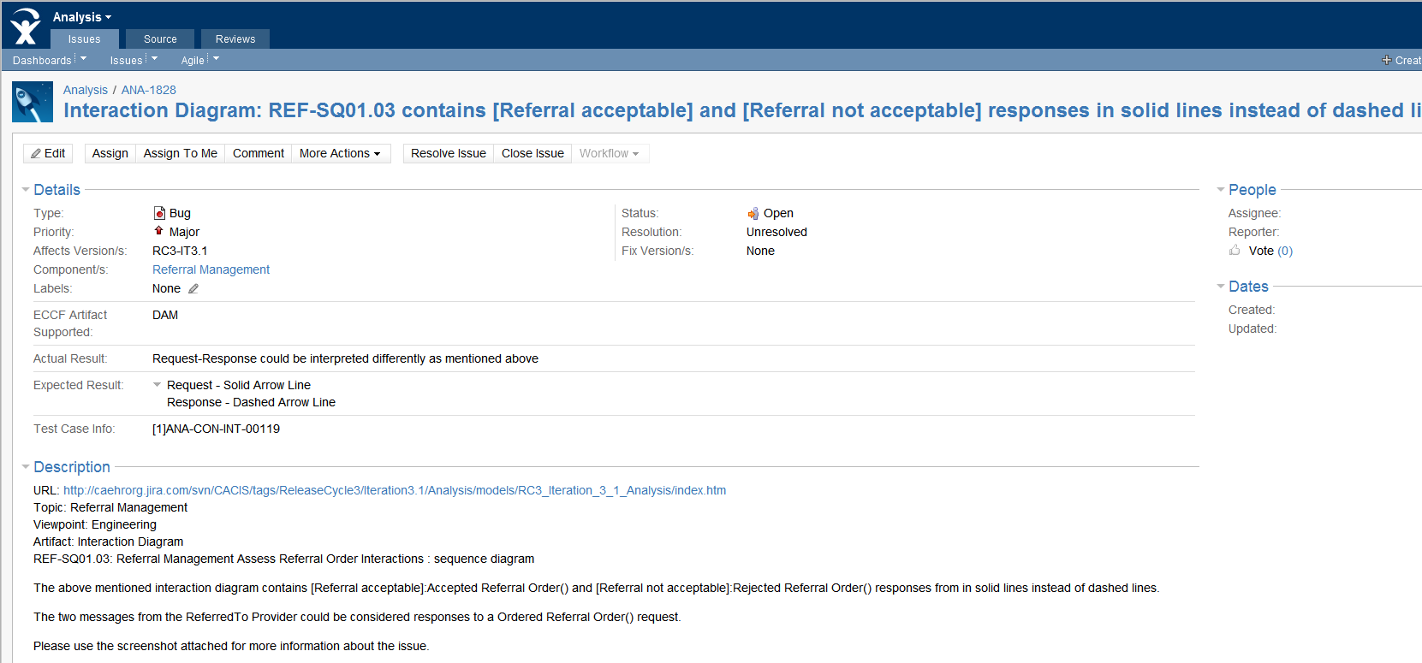

Repository Locations

Enterprise Architect
  - All UML Models are made in EA with some Visio plugins as applicable

SVN
  - All Model Artifacts
  - All Documents
    - All the documents displayed earlier
  - RC3-I3 URL: http://caehrorg.jira.com/svn/CACIS/tags/ReleaseCycle3/Iteration3/Analysis/

Contour
  - Requirement Statements
  - Also gives traceability between artifacts (if the associations have been created already)
  - URL: http://contour.caehr.net:8080/contour/

Wiki is the face of SVN
  - Publication Page
  - Lists applicable SVN Documents as delivered per publication
  - ANA Deliverables Page: https://wiki.nci.nih.gov/display/caEHR/Analysis_Deliverables
  - RC3-I3 URL: https://wiki.nci.nih.gov/display/caEHR/RC3+Iteration+3+Publication+(January+19,+2011)

Quality Center
  - http://hpqc.caehr.net:8080/qcbin/start_a.htm

JIRA
- http://caehrorg.jira.com/

Tool Access
QA reaches out to CDO for accessing any of the tools mentioned above.

Roles and Responsibilities
The following teams have roles associated with component testing:

Analysis DSL/Stream
Responsible for:
- Develop Use cases and requirements in collaboration with the Adopters. This forms the basis for test case development.
- Hand-off of analysis artifacts at the end of each iteration, including:
- Iteration delivery Release Notes
- Iteration delivery Manifest
- Iteration delivery Enterprise Architect modeling components
- Iteration delivery Word document based components (narratives, scoping documents, etc.)
- Other non-Enterprise Architect related artifacts, including:
- Scope and Vision documents,
- Meaningful Use Requirements interpretation documents.
- Evaluate and approve implementation of the requirements management tool.

Architecture DSL/Stream
Responsible for:
- CFSS – Conceptual Functional Service Specification
- PIM – Platform Independent Model
- PSM – Platform Specific Model
- Ensure requirements flow from CFSS to PIM
- Identification of Non-functional requirements

Development DSL/Stream
Responsible for:
- SAD – Software Architecture Document
- PSM – Platform Specific Model
- Ensure requirements flow from PIM to PSM
- Develop the system/application

QA DSL/Stream
Responsible for:
- Develop the Requirements Test Plan and other Test Plans across different topics
- Develop Test Cases per Functional Requirements and Technical Requirements
- Ensure requirements are linked to test cases and defects
- Create the Requirements Traceability Report

Continuous Delivery Operations (CDO) Stream
Responsible for:
- Support of the Continuous Delivery environment

Deployment DSL/Stream
Responsible for:
- Collecting Deployment use cases and requirements for each site and assuring they are adequately reflected in the project’s analysis artifacts
- Describing the Deployment scenarios for each site
- Executing the Deployment at each site
- Managing the interaction with the NCI/CBIIT-designated Cancer Center (known as NCI Community Cancer Center Program (NCCCP) selected and funded by CBIIT to undertake formal adoption, or adaptation of caBIG® Clinical Information Suite Project artifacts (specifications or software):
- Contribute to use case, requirement development through review
- Unique and specific requirements for their site
- Deployment at their site
- Conduct Full User Acceptance, and end-to-end testing; this includes identifying testing scenarios, building the test scripts, executing scripts and reporting test results.

Entry and Exit Criteria

Entry Criteria

Inventory Validations
Validating to ensure that all the specifications have been delivered as indicated in publication. Artifacts that cannot be traced onto the respective physical repository locations as mentioned above shall not be included into the scope of testing. Hence only the artifacts that can be traced successfully shall be included into the scope for testing.

Specification Maturity
QA Team shall pick up any artifact mentioned at a maturity index of “Working Document” or higher to be subjected for Verification and Validation process. Maturity and Change Types information can be obtained from –
https://spreadsheets.google.com/ccc?authkey=CIfau6IL&hl=en&key=tUPrsphkDe7yqcqjHblae1A&hl=en&authkey=CIfau6IL#gid=0

Levels of Testing
Basic methodology of testing ANA artifacts is consistent with the Master QA Test Plan’s strategy of addressing test cases per levels of complexity.

Deviations from Master QA Test Plan
Specification Validation deviates from Code Validation (or Payload/Technical Validation) due to the fact that validation in this stream is on Artifacts and Specifications and other Documents and not any Implementation or Coding outputs. Detailed levels of testing is elaborated below

Level 1
Basic and Binary checks whether entities or objects as defined in the test case exist in the specification. These are considered smoke tests for Artifacts.
Example:
- Verify if Table 1: Conformance Profile is present in the document
- Verify Author Review table is present
- Verify that Operation Interaction Diagrams are present

Level 2
These types of test cases validate for correlation of entity at a high level.
Example:
- Verify that for any interaction diagram present then there shall be description associated with it respectively.

Level 3
These test cases evaluate a thorough completeness and correlation of content inside the entire document or multiple documents combined
Example:
- Verify that Scope statement mentioned in the Introduction Section is consistent with use cases identified
- Use cases identified shall have corresponding interaction diagrams with consistent intent and meaning
- Verify that a use case shall be elaborated into corresponding activity diagram(s)
  - NOTE: if the tester evaluates that any information is missing, then the tester shall log an Event against the release/tag of the artifacts to the Analysis team.
    - Please use Template for Logging Events section for any additional information.

NOTE:
- It's assumed that Level 1 cases are executed and pass before proceeding to the next levels.
- If Level 1 test cases pass, then execution moves onto Level 2 and then onto Level 3.
- If Level 1 tests fail, then any other associated test cases based on the entity under consideration shall be deemed failed as the basic binary check didn’t pass through.
  - Please follow Defects section below for any additional information.

Exit Criteria
Testing is considered as complete after all the test cases identified against artifacts that are identified as “Testable” have been executed per iteration’s publication.

For additional information on “Testable” Artifacts, please refer to MSS at - http://caehrorg.jira.com/svn/CACIS/trunk/documents/QA/Test_Reports/Master Service Status.xls

Testing Environment
The artifacts are of type -
- EA outputs,
- Word Documents and
- Browser based artifacts
There isn’t any additional requirement for a dedicated testing environment per say, to verify the stack of specifications. Please use the “Tools and Repository Locations” for additional information.

In addition to the tooling mentioned above, QA Team shall utilize the following resources to test the specification stack –

Operating Systems: Windows, Apple (Any Versions)
Browsers: IE, Mozilla, Safari (Any Versions)
Documents: Microsoft Office (2003, 2007 and/or 2010 versions)

If the nature/type of artifact changes in the future, this section shall be updated accordingly in subsequent releases.

Specification Testing Strategy or Testing Methodology
Verification Strategy to be adopted in ANA Artifact Verification is -
- Consistency between various artifact types identified above
  - Intent, Meaning and Message being conveyed is consistent based on the artifact types
  - Correlating content between artifact types
- Inventory Check of ANA Publications
- Completeness of artifacts within the delivered Publication
  - Gaps
  - Missing pieces
  - Contradictions
  - Duplicates
- Traceability Aspects (under progress)
NOTE: QA Team is currently working on aligning testing activities towards “Vertical Alignment” of testing resources that would start from a CIM Level Artifact and continue specification validation until a PSM level artifact is complete. More information shall be published in future releases.

Verification Methodology
Specification Verification adopted the route of de-coupling Content Validation from ECCF Process Compliance and the order of verification is as depicted below. It starts from the inner most circle – “Each Artifact – Standalone” and expands onto outer circles adding additional scope after completing each stage. Additional information of each activity is explained below.
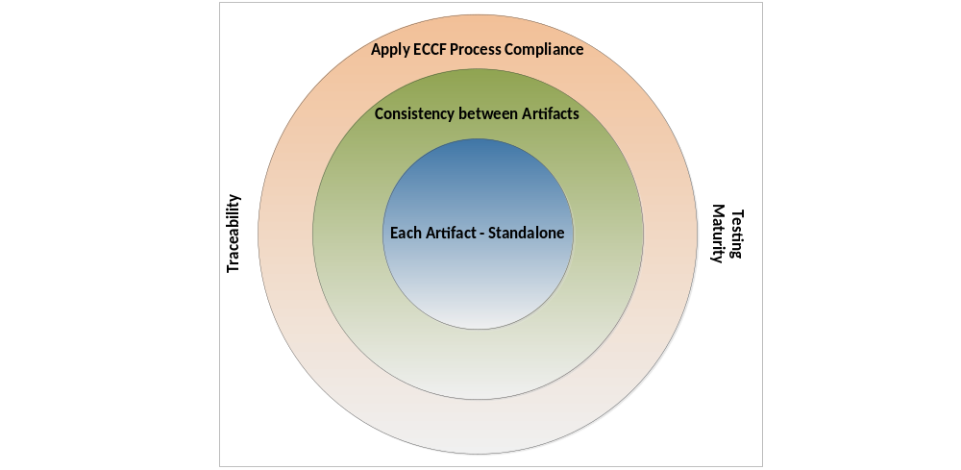

Each Artifact Standalone
Sample Standalone Verification factors to include (but not limited to)
- Content:
- Use Case-Event Flow Mapping is defined sufficiently
- Activities have only one starting and appropriate ending point(s)
- Swim lanes are identified with appropriate actors, defined from Use Cases
- Events and Information exchange –
  - sequence of events within a given activity
  - Actors across swim lanes
  - Information Exchange between any 2 activities
- State Transitions that an information object(~data) moves through
- Lifelines of actors while in message exchange is valid
- Every Interaction has a respective Use Case
- Requests shall have appropriate responses as acknowledgement messages
- State Transitions of objects in Activity Diagrams match with State transitions as defined in State Machine Diagrams
- Class Attributes, Methods are defined with access modifiers indicated for each class member
- Cardinality of each Class and each Class Member(s) have been identified
- Association between classes is established

- Structure:
- Naming Conventions
- Hierarchy between Major and/or Sub Event Flows (inline activity diagrams)

Consistency between Artifacts
The following approach is used in order to correlate the content flowing from one artifact onto another.
  - Intent, Meaning and Message being conveyed is consistent between different artifact types
  - Correlating content between artifact types
  - Completeness of artifacts within the delivered Publication
    - Gaps
    - Missing pieces
    - Contradictions
    - Duplicates
The following diagram depicts Verification method adopted for Standalone Verification and Consistency between Artifacts Specification Verification Processes.

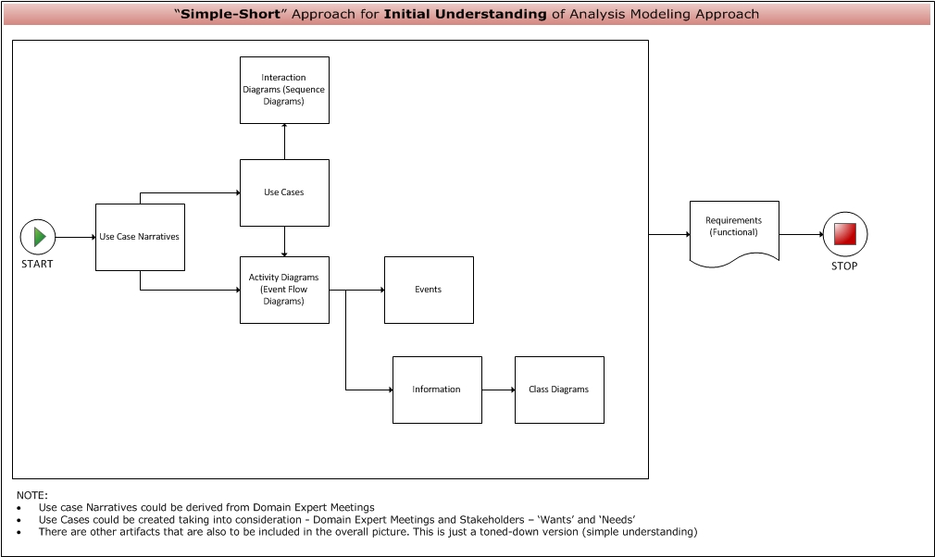

Apply ECCF Process Compliance
Additional Scope of Testing also involves ensuring specification stack is in line with expected ECCF Specification Guidelines. This topic is under preliminary discussions and isn’t matured or evolved. The following is a snapshot of grid representing ODP Viewpoints Vs. MDA Layers of Specifications that ECCF process adopted.

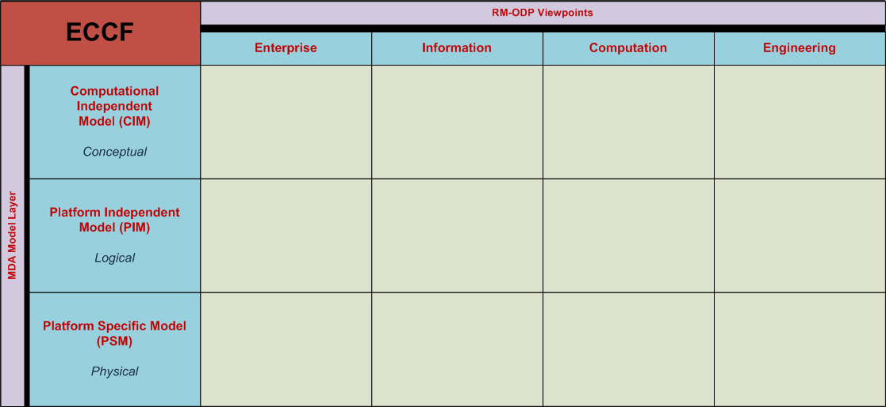

This section shall be expanded based on any further details by Release Cycle 4.

Traceability
Traceability issues as on Release Cycle 3, Iteration 3 are still being discussed. Discussions around –
- Depth and Breadth of Traceability
- Artifact Involved in Traceability
- Tools necessary to achieve this
- Teams involved to make this happen
- Frequency and other logistical issues

This section shall be expanded based on any further details by Release Cycle 4.

High Level Traceability Vision
The organization and structure of caBIG® artifacts for traceability should address the caBIG® requirement for publication of these artifacts into topics of relevance for the broad community of stakeholders. An enumerated list of "Business Capabilities" will be the root of that organization. This list will enable tracing to more detailed analytical, specification and software artifacts, while allowing forward planning and engagement.

Modest traceability between the specifications and the Ambulatory Oncology EHR Functional Profile will also need to be established to be able to support coverage verification. The extent to which the functional profile does or does not become the traceability path to the Clinical Oncology Requirements for an EHR (CORE) or St. Joseph's of Orange requirements needs to be determined.

This section shall be expanded based on any further details by Release Cycle 4.

Sample Use Case to Test Case Traceability
The use of requirements for the development of a caBIG® system from the beginning to the end of the project implementation can be refined as follows:
- Use Cases (UC) verified by Domain Experts (DE),
- Conceptual Functional Service Specifications (CFSS) based on the Use Cases,
- Platform Independent Model (PIM) specifications
- Test cases designed to test specific requirements
- Test cases to validate platform specific models (i.e. PSM, SAD).

Illustrating a clear path of a requirement from UC to CFSS to PIM to Test case is referred to as “requirements traceability”.

Sample Traceability Attributes
Requirements traceability reporting is expected to provide the following information (but not limited to):
Requirement Number – All requirements will be identified by a unique ID.
Use Case Number – A unique ID will identify all Use Cases.
UC Text – Brief description of the requirement from the Use Case.
CFSS – A reference to where the requirements are referenced in the CFSS.
PIM – A reference to where the requirements are referenced in the PIM.
PIM Text – Brief description of the requirement as it is described in the PIM.
Test Case Number – A unique ID will identify all Test Cases.
Test Case Category – Test Case categories will help quantify where defects occur more frequently in the software.
Defect Number – A unique ID will identify all Test Cases.

Sample Traceability Report
A sample requirements traceability report is shown on the following page:
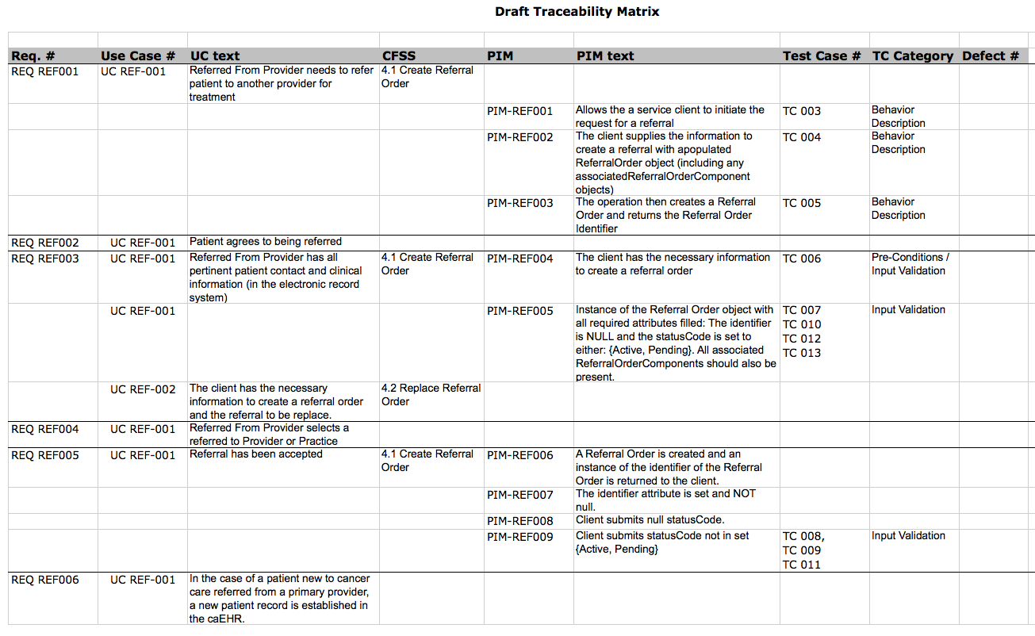

Testing Maturity
Testing maturity is currently being tracked on ‘Number of cycles of testing’ per Iteration. QA has been finishing testing of all Iteration’s published artifacts within that iteration.

This section shall be expanded based on any further details by Release Cycle 4 as details on the process mature enough.

Test Case Creation

Inputs Considered for Test Case Creation
The following artifacts are currently being considered (but not limited to) as inputs during test case creation –
- Analysis Modeling Guidelines
- Analysis Modeling Process
  - QA Adopted Simple Short Approach
- Directions, Pointers and Information received during Analysis Publication Handoff meetings
- Defects as applicable

The additional scope to be included in test case creation process is – absorbing the impact of Requirements Traceability, Additional Artifacts and Specifications if introduced.

Evolving Process
Test Case Creation shall be an evolving process that constantly looks out for improvements, additional information to validate specifications and other verification factors contributing towards test case creation process.

This section shall be expanded based on any further details by Release Cycle 4.

Test Execution
- All test case execution happens in Quality Center
- Bring all the impacted artifact’s test cases into test lab per planned scope
  - so before beginning the test case execution, all impacted artifact’s test cases/scripts are in No Run status
- Start executing test cases
- Indicate Bug ids in actual results for any failed test case(s)
  - Indicate all applicable JIRA Bug IDs in actual results and also in the JIRA Defect ID column against respective test case in QC’s test lab
- A defect/question shall have at least one test case marked as fail.

Event Handling Mechanism

What are Events?
Any inconsistencies or differences observed while verifying the above mentioned specification stack is considered in general – an Event. QA logs, in the JIRA system, the following types of events based on the guidelines listed below -

Defects
The following factors contribute towards logging a defect (but not limited to) –
- Consistency mismatch between various artifact types identified above
  - Intent, Meaning and Message being conveyed is not consistent based on the artifact types
  - Unable to correlating Content, Intent, Meaning and Message between artifact types
- Inventory Check of ANA Publications fails
- Completeness issues of artifacts within the delivered Publication
  - Gaps
  - Missing pieces
  - Contradictions
  - Duplicates

Questions
For any information that’s needed to understand the delivered specifications, a question shall be raised.

Template for Logging Events
The following fields/details shall be provided while logging defects to Analysis as appropriate in the defect’s description field:
- URL: <URL of EA/SVN artifact’s location
- Topic: <Referral Management>
- Viewpoint: <Computational>
- Artifact: <Example>: Use Case, Event Flow
  - Use Case:
    - REF-UC01.00-Create Referral Order
    - REF-UC02.00-Update Referral Order
  - Event Flow:
    - REF-EF02.01-Create Referral Order
    - REF-EF02.02-Update Referral Order
NOTE: All applicable artifacts shall be listed
- Detailed description of the defect
- Expected Result (from test case)
- Actual Result
- Test Case ID
- JIRA Affects Version- this is the publication’s iteration
- Assign to – “<ANA POC>” NOTE: Please reach out to testers for this information.
- Attach any screenshot to help facilitate identifying the issue
  - Please use – ANA-1814 as a reference

Risks, Dependencies, Constraints
Risks, Issues, Constraints shall be in line with Master Test Plan Document. In addition to those mentioned in the Master Test Plan, below mentioned are specific towards Requirements Test Plan
- Maturity of Analysis Publication impacts the depth and extent of testing that can be done over the published specifications
- Defect resolution
- Testing Maturity of Specification Verification
  - Number of cycles of testing per Iteration
- Artifact and Requirement Traceability Issues could impact in a change of Strategy and Methodology of verifying the above mentioned specifications

Reporting
Requirements Test will produce the following key artifacts:
Artifact # | Artifact Name | RFP Deliverable Reference | Key inputs / Dependencies | Expected Content
96 | Requirements Test Plan | Test plan document | Functional and Non-functional requirements | This document
97 | Requirements Test Report | System test report | System tests | Report potion of requirements satisfied by Iteration build
104 | Requirements Traceability Report | System test report | System and Requirements Test Report | Release-based report indicating requirements included in release

Sample Reporting Structure

Sample Artifact Test Case Distribution Report
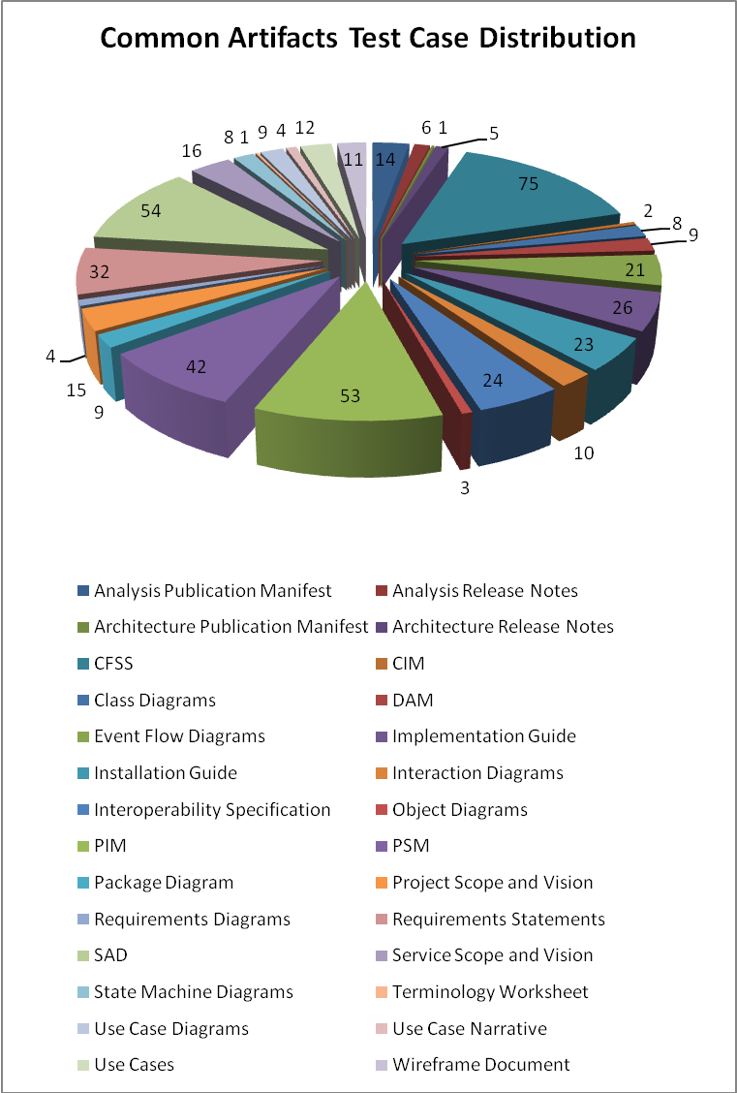

Sample Execution Status Report
R3-I3 | Delivered | Testable |  | Tested
CFSS | 30 | 18 | 60% | 12 | 67%
CIM | 16 | 2 | 13% | 1 | 50%
PIM | 19 | 12 | 63% | 7 | 58%
PSM | 7 | 5 | 71% | 5 | 100%
Totals | 72 | 37 | 51% | 25 | 68%

Sample Bug Status Report
 | Open | Reopened | In Progress | Dev Fixed | Resolved | Closed | Grand Total
Analysis | 118 | 8 | 11 |  | 11 | 42 | 190
Bug | 96 | 7 | 9 |  | 2 | 37 | 151
Question | 22 | 1 | 2 |  | 9 | 5 | 39
Architecture | 162 | 6 | 52 |  | 45 | 224 | 489
Action |  |  |  |  |  | 1 | 1
Artifact Maturity | 135 | 5 | 50 |  | 11 | 113 | 314
Bug | 23 | 1 | 2 |  | 23 | 53 | 102
Question | 4 |  |  |  | 11 | 55 | 70
Task |  |  |  |  |  | 2 | 2

